**NAME: VARSHA**

**USN:1NT19IS182**

**Inserting one value in the database**

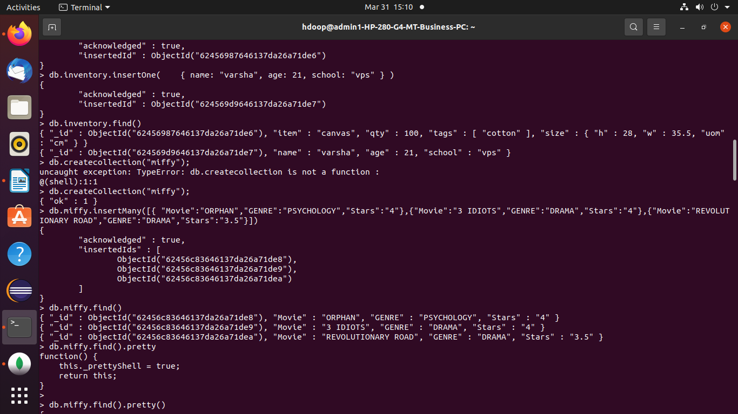

**Creating database “miffy” and inserting many values and displaying it**

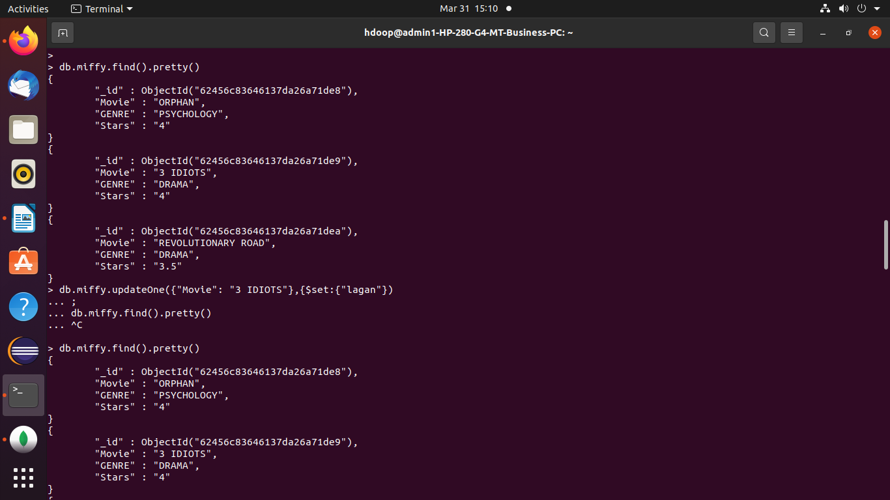

**Updating one value**

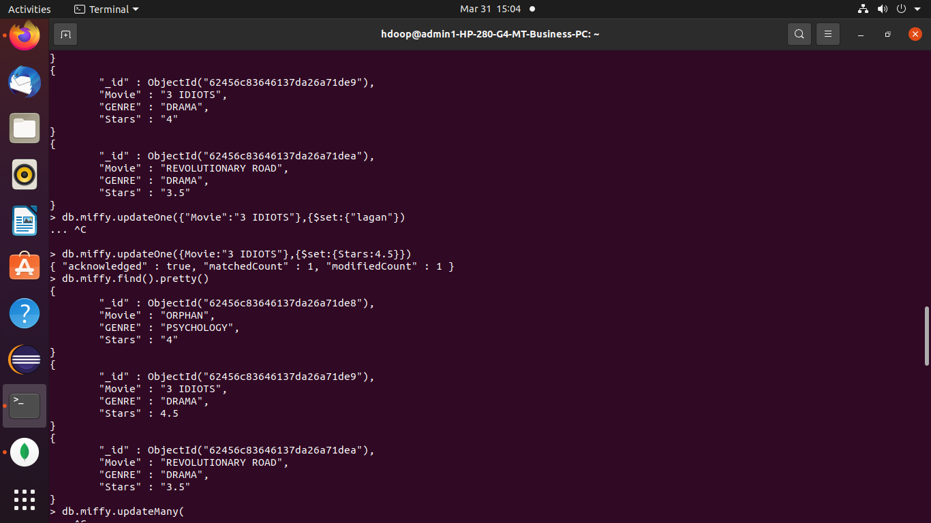

**Updating multiple values in database**

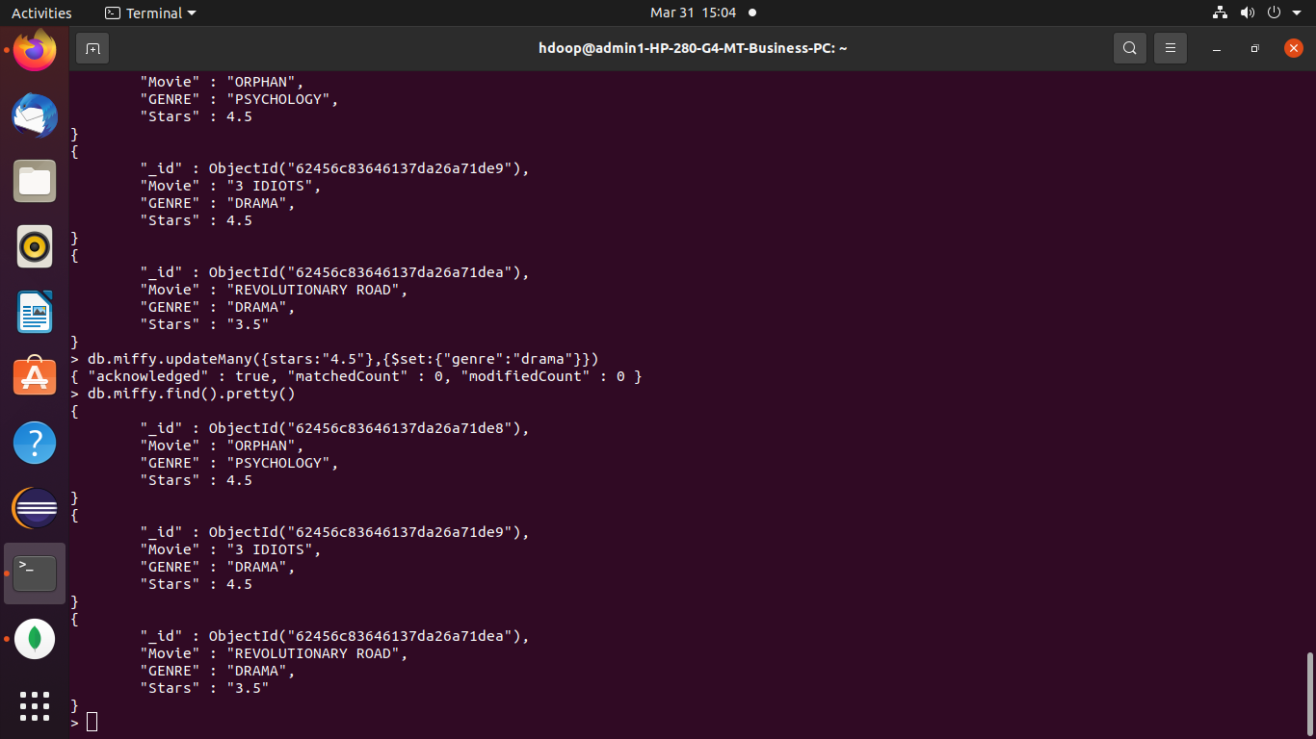

**Deleting many values and one value**

